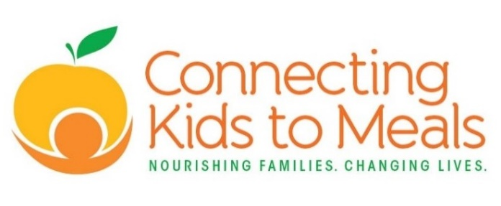 | MEAL SITES  (Starting Sept. 8, 2020)

Birmingham Library | 203 Paine Ave. 43605 | M-F | Breakfast & Lunch | 4:00 - 5:00 pm
Connecting Kids To Meals | 1501 Monroe St. (16th St entrance) 43604 | M-F | Breakfast & Lunch | 4:00 - 5:00 pm
Heatherdowns Library | 3265 Glanzman Rd. 43614-3809 | M-F | Breakfast & Lunch | 4:00 - 5:00 pm
Holland Library | 1032 S McCord Rd, 43528 | M-F | Breakfast & Lunch | 4:00 - 5:00 pm
Homer Hanham Boys & Girls Club | 2250 N Detroit Ave. 43606-4641 | M-F | Breakfast & Lunch | 4:00 - 5:00 pm
Kent Library | 3101 Collingwood Blvd. 43610 | M-F | Breakfast & Lunch | 4:00 - 5:00 pm
LaGrange Library | 3422 Lagrange St. 43608 | M-F | Breakfast & Lunch | 4:00 - 5:00 pm
Locke Library | 703 Miami St. 43605 | M-F | Breakfast & Lunch | 4:00 - 5:00 pm
Mott Library | 1010 Dorr St.  43607 | M-F | Breakfast & Lunch | 4:00 - 5:00 pm
Oregon Library | 3340 Dustin Rd. 43616 | M-F | Breakfast & Lunch | 4:00 - 5:00 pm
Padua Center | 1416 Nebraska Ave. 43607 | M-F | Breakfast & Lunch | 4:00 - 5:00 pm
Reynolds Corners Library | 4833 Dorr St.  43615 | M-F | Breakfast & Lunch | 4:00 - 5:00 pm
South Toledo Library | 1736 Broadway St. 43609 | M-F | Breakfast & Lunch | 4:00 - 5:00 pm
Toledo Heights Library | 423 Shasta Dr. 43609 | M-F | Breakfast & Lunch | 4:00 - 5:00 pm
Toledo Main Library | 325 N. Michigan St. 43604 | M-F | Breakfast & Lunch | 4:00 - 5:00 pm
Washington Library | 5560 Harvest Lane 43623 | M-F | Breakfast & Lunch | 4:00 - 5:00 pm
West Toledo Library | 1320 Sylvania Ave. 43612 | M-F | Breakfast & Lunch | 4:00 - 5:00 pm

This institution is an equal opportunity provider.

